**School Management System Project**

**Mastering Embedded Systems Diploma**

[www.learn-in-depth.com](http://www.learn-in-depth.com)

First Term (Final Project 2)

**Eng. Amr Esaam Mohammed Zidan**

My Profile: <https://www.learn-in-depth.com/online-diploma/amresaam1342000%40gmail.com>

Contents

1.Case Study………………………….. 1

•Requirements……………………………….. 2

•Assumptions……………………………….. 2

•Versioning……………………………….. 2

2.Method 2

Software Development Lifecycle and Software Testing Lifecycle 2

3.System Requirements………………………….. 3

Requirement model 3

4.Design Space Exploration………………………….. 4

4.System Analysis 4

•Use Case Diagram……………………………….. 4

5.System Design 5

•C Codes……………………………….. 5

school_fifo 5

Main 17

Code Building Tools 18

GCC Compiler 18

Working Code 19

1.Add students manually………………………………….. 19

2.Add students from file………………………………….. 20

3.Show students from added file………………………………….. 21

4.Counting students………………………………….. 22

5.Finding a student with roll number………………………………….. 22

6.Finding a student with first name………………..................... 22

7.Finding a student with course id………………………………….. 23

8.Deleting a student………………………………….. 24

9.Updating student's roll number………………..................... 24

10.Trying operation while FIFO is empty………………………………… 25

# 

# Case Study

## Requirements

The client requires a system with the following specifications:

1. Adding students to the system manually and using a text file.
2. Finding student's data through (roll number, first name and course id).
3. Find the count of the total students on the system.
4. Delete student's data from the system.
5. Update student's data on the system.
6. Show all students' data on the system.

## Assumptions

The following assumptions are made:

1. The school's computers meet the minimum requirements for the application to run.
2. No storage on the computer's hard drive.

## Versioning

1. The possibility of adding a function to delete all students.
2. The enhancement of error handling in all corner cases.

# 2.Method

## Software Development Lifecycle and Software Testing Lifecycle

The (SDLC) and (STLC) will be approached based on the V-Model.

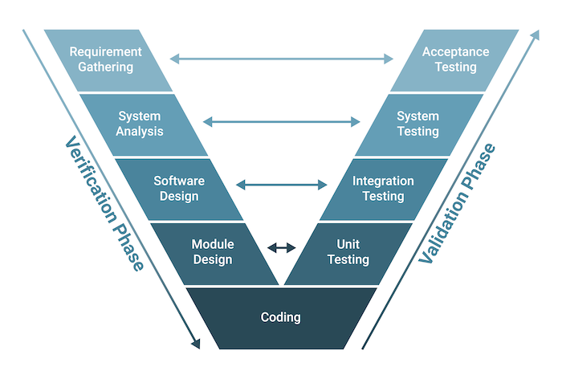

Requirements Gathering and Analysis: The first phase of the V-Model is the requirements gathering and analysis phase, where the customer’s requirements for the software are gathered and analyzed to determine the scope of the project.

Design: In the design phase, the software architecture and design are developed, including the high-level design and detailed design.

Implementation: In the implementation phase, the software is actually built based on the design.

Testing: In the testing phase, the software is tested to ensure that it meets the customer’s requirements and is of high quality.

Deployment: In the deployment phase, the software is deployed and put into use.

Maintenance: In the maintenance phase, the software is maintained to ensure that it continues to meet the customer’s needs and expectations.

The V-Model is often used in safety-critical systems, such as aerospace and defense systems, because of its emphasis on thorough testing and its ability to clearly define the steps involved in the software development process.

# System Requirements

## 

## Requirement model

# Design Space Exploration

To run the system on the school's computers a PC with at least windows 10 must be available.

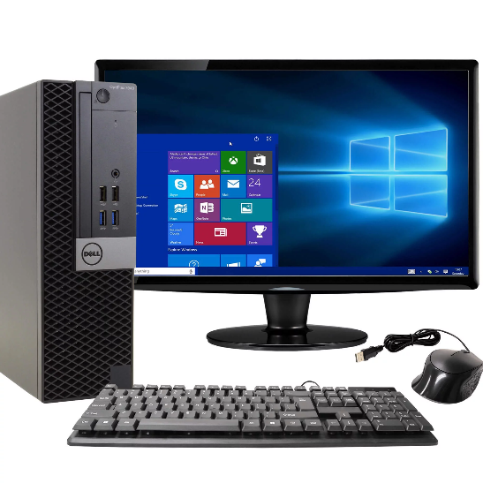RAM: 4GB

CPU: Core i3 7th Generation

Graphics Card: No recommendations

GCC Compiler

Standard C Libraries

# 4.System Analysis

## Use Case Diagram

# 5.System Design

## C Codes

### school_fifo

.c files

FIFO_init

FIFO_IS_FULL

FIFO_check_id

FIFO_add_student_file

FIFO_add_student

FIFO_find_roll_num

FIFO_find_first_name

FIFO_find_course

FIFO_count

FIFO_ delete_student

FIFO_ update_student

FIFO_ show_info

.h file

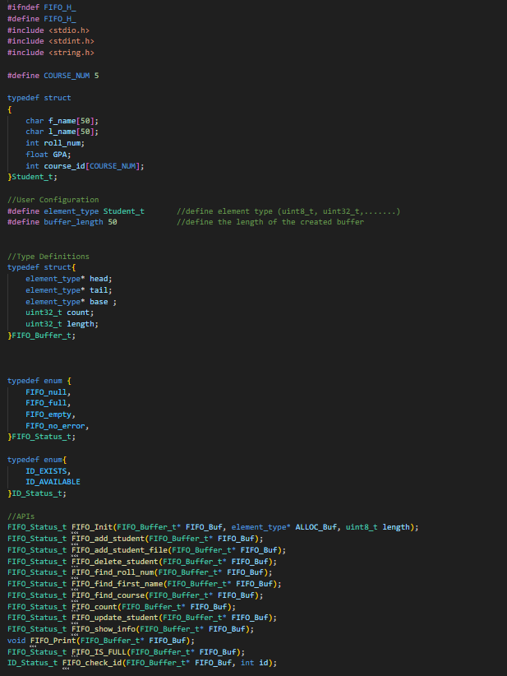

### Main

.c file

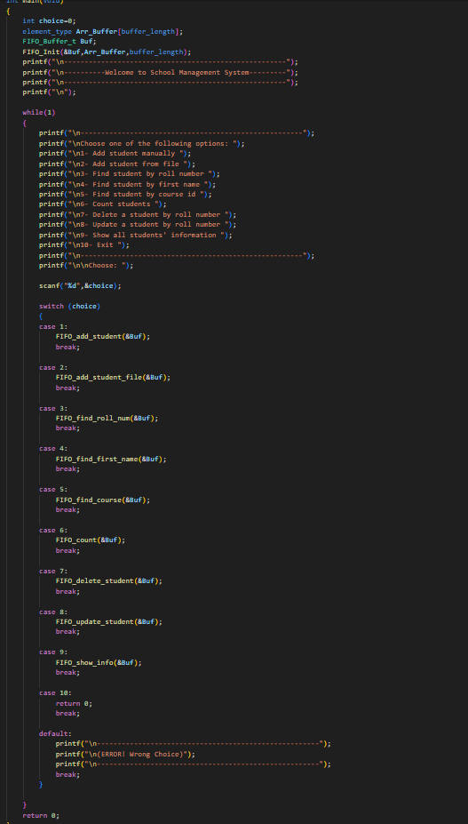

## Code Building Tools

### GCC Compiler

## Working Code

### Add students manually

### Add students from file

### Show students from added file

### A black and white screen with white text Description automatically generatedCounting students

### Finding a student with roll number

### Finding a student with first name

### Finding a student with course id

### Deleting a student

After deletion:

### Updating student's roll number

### Trying operation while FIFO is empty

